

Project ID: SCE14-0491

**Cluster Analysis On Dynamic Graphs**

Submitted by Samuel Eng Ming Guang

Matriculation Number: U1322185F

Supervisor: Asst Prof Kelly Ke Yiping

School of Computer Engineering

A final year project report presented to the Nanyang Technological University

in partial fulfillment of the requirements of the degree of

Bachelor of Computer Science 2015

# 

# Abstract

Graph clustering on large dynamic networks poses a challenge to many important fields such as social networking analytics and bioinformatics. In the context of communication networks like Twitter, emerging topics can be detected while in citation networks the focus is on identifying research areas. All of these issues can be solved by modeling the data as a graph and applying clustering techniques where the found sets are called clusters. This project aims to study the clustering problem on dynamic graphs that evolve over time. The report begins by introducing three different graph clustering algorithms namely, *Markov Clustering* (MCL), *Multi-level Regularized Markov Clustering*(MLR-MCL) and *Chinese Whispers Clustering*(CW) that were implemented and analyzed in this project. Dynamic graphs are first divided into different time dimensions to have a set of intervals where each set is considered a time step snapshot. This simulation of graph snapshots with temporal edges allows us to analyze the evolution of the dynamic network. Clustering is then done independently on each snapshot using a static clustering algorithm to detect communities. A visual model is implemented to link the clustering results of consecutive snapshots together with a threshold function. Furthermore, the model allows tracing of individual nodes that potentially could be useful for internal analysis of clusters. With these functionalities, cluster information can be made more beneficial for further analysis.

# Acknowledgments

The preparation and writing of this report faced many challenges. In particular, as a student who is also undergoing industrial orientation for three months and also working part time during school hours, I could not devote myself full-time to this project.

Nonetheless, this report could not be researched and compiled without the assistance and guidance of my supervisor. Thus, I would like to convey my deepest gratitude to Assistant Professor Kelly Ke Yiping, who guided me throughout the year. Her continuous motivation, suggestions and support helped me immensely in successfully completing this project.

**Table Of Contents**

Abstract 2

Acknowledgments 3

1. Introduction 8

1.1 Background 8

1.2 Purpose and scope 9

1.3 Contributions 10

1.4 Organization of report 10

1.5 Project Schedule 12

2. Preliminaries: Notations and Definitions 13

2.1 Markov Chain 13

2.2 Column Stochastic Matrices and Flow 13

2.3 Deriving Column Stochastic Matrices 14

2.4 Degree 14

2.5 Neighborhood 14

2.6 Class Matrix 14

3. Clustering Algorithms 15

3.1 Markov Clustering Algorithm (MCL) 15

3.1.1 Self-Loops 15

3.1.2 Expansion (power of 2) 15

3.1.3 Inflation (r = 2) 16

3.1.4 Pruning (threshold = 0.25) 16

3.1.5 Convergence and Interpretation 16

3.1.6 Analysis 17

3.2 Multi-level Regularized MCL (MLR-MCL) 18

3.2.1 Coarsening 19

3.2.2 Curtailed R-MCL 21

3.2.3 R-MCL on original graph 22

3.2.4 Multi Core-Processing 22

3.2.5 Analysis 23

3.3 Chinese Whispers Algorithm (CW) 25

3.3.1 Special case of MCL 26

3.3.2 Analysis 27

4. Visualization of evolving clusters 29

5. Software resources 31

5.1 Application architecture 31

5.1.1 JAVA and JAVAFX 31

5.1.2 Development tool - NetBeans 31

5.2 Libraries 32

5.2.1 Graph Stream 32

5.2.2 Guava 32

6. Design documentation 33

6.1 Clustering Algorithms 33

6.1.1 Snapshots 34

6.1.2 Detailed cluster results 36

6.2 Linking and analysis 36

6.2.1 Threshold 39

6.2.2 Tracing 42

6.3 Experimental Results: 44

6.3.1 Performance 44

6.3.2 Comparison Results 48

7. Conclusion 53

8. Future work 54

References 57

End Section 59

Appendix A 59

Algorithms functionality 59

Visual model functionality 61

Appendix B (Test results) 67

Number of Nodes involved 67

Appendix C (Visual Model Instructions) 72

# 

# 

# 

# 

# 

**Table Of Figures**

Figure 1: MLRMCL operations - (Venu Satuluri 2012) 19

Figure 2: Maximal Matching 20

Figure 3: Matching pairs 20

Figure 4: Mapping to supernodes 21

Figure 5: Clustering based on classes – (Chris Biemann 2011) 26

Figure 6: Converging problem - (Chris Biemann 2011) 27

Figure 7: Bipartite graph Figure 8: Graph size matters for split-(Chris Biemann 2011)…………….. 28

Figure 9: Evolutionary clustering strategy - (Tanja Hartmann 2014) 29

Figure 10: Snapshot at time step 1 Figure 11: Snapshot at time step 2 34

Figure 12: Hash map to CSV format 35

Figure 13: Node details displayed at each cluster 36

Figure 14: Tracking node information in clusters 37

Figure 15: Visualization model 38

Figure 16: Continuous time intervals 40

Figure 17: Threshold at 30% 41

Figure 18: Tracking node ID 80 42

Figure 19: Reappearing node ID 78 43

Figure 20: Average N-CUT of MCL and MLRMCL (Macro Gaertler and others 2011) 47

Figure 21: Number of clusters involved in graphs 50

Figure 22: Number of overlapping nodes in each graph 51

Figure 23: Dynamic update strategy – (Tanja Hartmann 2014) 55

# 

# 

# 

# 

# 1. Introduction

## 1.1 Background

Cluster analysis is about identifying the heterogeneity structure of any non-uniform data. In graph context, clustering means grouping vertices based on the edge structure, forming many vertices within one cluster and just a few edges between clusters. A graph cluster can be described as a maximal clique of a graph.

Graph clustering is vital to many applications in different fields. From discovering community’s social networks, grouping data on human interaction to protein folding. Computer scientists have realized the importance of identifying these sets and proposed many clustering algorithms.

Historically, graph clustering focused on studying static graphs. This is not realistic because almost all real networks are dynamic and huge. The difficulty of studying dynamic graphs lies in how to deal with large graphs, obtaining good quality clusters and linking up clusters in consecutive snapshots to perform clustering evolvement. The evolution of a graph usually consists of two common concepts. The first concept is based on capturing snapshots of the graph where each snapshot corresponds to a certain time step. The difference of two consecutive snapshots produce vertices and edges changes. The second concept consists of a reversed fashion where vertices and edges changes induce a new snapshot and time step. Iteratively cluster snapshots of a huge dynamic graph using a static clustering method have its disadvantages. Firstly, the runtime is non-trivial and cannot be ignored for large instances of snapshots since clustering is executed from scratch in each time step. Secondly, computing power is a big concern, even for fast linear clustering methods such as the *Chinese Whispers Clustering* algorithm. Lastly, it is impossible to process a huge graph on a single machine because of the memory wall limitations.

## 1.2 Purpose and scope

Clustering occurs all around our daily lives. Even a company’s human resource safety committee may be regarded as a cluster of people. Biologists must organize different species of animals before coming up with a meaningful description of their differences. In medicine, clustering of different diseases leads to taxonomies of illnesses.

Apart from analyzing the clustering results in each snapshot of an evolving graph, further steps are required to make the clustering result interpretable and meaningful for further analysis. Intuitively, the first question would be how the communities evolve over time. One approach is to use a non-classical definition of communities which allows to follow the evolution of dynamic network using a simple set of rules (birth, death, merge, split, growth and contraction).

Human experts will eventually have to interpret the meaning of the clusters, but it is necessary to present the algorithm results in a clear and readable form. In this project, a visualization library was implemented to handle cluster interactions based on a given similarity measure. Finally, the evaluation of the clustering results is discussed using the graphical interface designed in this project.

## 1.3 Contributions

In this project, clustering algorithms of different constructions and background are integrated into a similar format for reading. Firstly, *Markov Clustering* algorithm is well researched and readily available but *Multilevel Regularized Markov Clustering* algorithm is a multi-level mapping clustering algorithm that is less well known because of its slightly complicated nature. The latter’s superior quality was investigated and designed to fit into the visual model as well. Lastly, because of its linear time complexity and less studied background, it was a motivation to implement *Chinese Whispers Clustering* algorithm and test its performance on the visual model. All 3 algorithms use the same utility class that is easily extendable to other future algorithms to provide similar inputs for the visual model.

For dynamic graphs, one of the ways to analysis clusters is to track cluster edges and filter out clusters that do not meet a certain threshold value. The visual model provides a more text-based information for the user such as showing every cluster threshold value and a number of overlapping nodes in it. In addition, the visual model also allows the user to track each node’s lifespan throughout a timeline and understand where it splits or appears at any point of time. With these functionalities, the project aims at viewing the variety of available data and providing an interface for users in order to help them find reasonable test instances for a specific algorithm.

## 1.4 Organization of report

The technical documentation begins at Chapter 2 where notations and definitions were first introduced in order to explain the terms used in this report.

Next, Chapter 3 introduces the clustering algorithms that were implemented in this project. The structure of the algorithms is explained specifically and each algorithm are discussed respectively in terms of its strengths and weaknesses. Chapter 4 follows up the work from the previous chapter by introducing the visual model and how it is being constructed. In Chapter 5, software tools and resources are introduced to demonstrate how the applications were implemented. Chapter 6 is described below. Finally, in Chapter 7 and 8, the report is concluded by evaluating the work that is being done, the problems that are being encountered and the areas of future work which can be done.

The design technical documentation for the software component of this project is described in Chapter 6. This includes how the clustering algorithms provides detailed data for the visual model to analyze and display in its own format. Experimental results were tested to show that meaningful data could be mined from this software. Specific details on how to use the applications are described in Appendix C.

## 1.5 Project Schedule

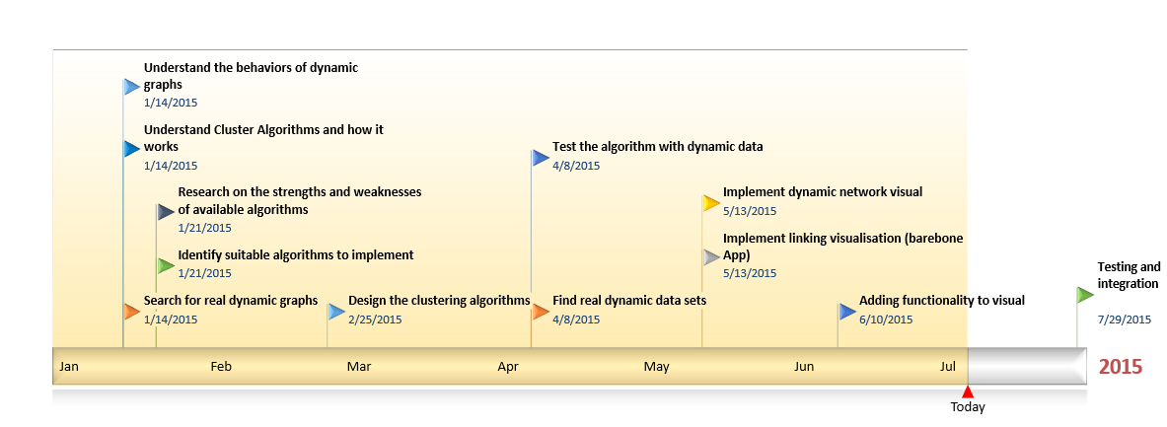

The project focuses on mainly graph clustering algorithms. Since all three clustering algorithms are related, it did not take long to construct the rest of the algorithms once MCL was finished. Since research on multi-level mapping techniques has to done in order to construct MLR-MCL, it took the longest time to implement. Testing of the algorithm was especially tedious since accuracy is foremost important. There were many bugs encountered during the period of April to July that might seem trivial but are difficult to trace the root of the problem. Graph Stream library is chosen because of its simplicity and powerful capabilities and the basic running application is constructed fairly quickly. Adding functionality to the visual to make it more interactive proved to be more time consuming as it makes use of the more advanced APIs.

# 2. Preliminaries: Notations and Definitions

Let G = (V, E) where G is the input graph with V and E denoting the vertices set and edge set respectively. Let A be a |V|*|V| adjacency matrix that constructs the graph, with A[i][j] representing the weight of the edge between vertex i and vertex j. In this project, graphs are considered undirected, hence A[i][j] will be a symmetric matrix.

## 2.1 Markov Chain

Markov Chain is a random mathematical process where the next state is dependent on the previous state. The state transition from one state to another is probability based.

## 2.2 Column Stochastic Matrices and Flow

A column-stochastic matrix M is a matrix of order N * N, where N is the number of nodes in a graph and every column sums to 1. It is interpreted as a matrix of transition probabilities of a Markov chain on the graph. The ith column of M represents the transition probabilities of the vertex Vi, and thus M[j][i] represents the probability of state transitions from vertex Vi to vertex Vj. This transition probability is also referred to as stochastic flow or just flow from Vi to Vj.

## 2.3 Deriving Column Stochastic Matrices

Each column in an adjacency matrix A is row-normalized to a sum of 1.

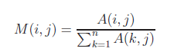

In matrix notation, M = A*D^(-1) where D is the diagonal degree matrix of G such that .

### 

## 2.4 Degree

The degree of a node is the number of edges a node takes part in.

## 2.5 Neighborhood

The neighborhood of a node v is denoted by the set of nodes v’ where (v,v’,w) of element E or (v’,v,w) of element E; it consists of all nodes that are connected to v.

## 2.6 Class Matrix

The class matrix Dg of G is an N * N matrix where rows denotes nodes and columns denote classes (Ci) = C. At d(i,j) of row i and column j represents the amount of V(i) belonging to a class C(j).

# 

# 3. Clustering Algorithms

## 3.1 Markov Clustering Algorithm (MCL)

Introduced by van Dongen(2000) [12], the *Markov Clustering Algorithm* (MCL) is a clustering method that is aimed to solve graph clustering paradigm. Based on the simulation of transition probabilities similar to Markov Chains, it is an elegant algorithm that has gained worldwide popularity in bioinformatics.

Using sequential operators - Expansion, Inflation, and Pruning, MCL successively process these steps until convergence. To represent the graph, an adjacency matrix A and a canonical transition matrix, M := (A + I)D^-1 is used.

### 3.1.1 Self-Loops

Before the algorithm runs, self-loops are added to the input graph. The formula can be described as A := A + I. This avoids dependence of the flow distribution on the length of the random walk simulated along the process and also ensures at least a minimum of one non-zero entry for each column.

### 3.1.2 Expansion (power of 2)

Expansion increases the flow to probable connected nodes along with new nodes. Given an input flow matrix G, expand brings the flow out of a selected vertex to potentially new vertices. In addition, it also smoothens the flow to the vertices since each vertex can be reached by numerous paths. Thus, expansion can be expressed as M := M*M. That is the ith column of M can be interpreted as the final distribution of a random walk of length 2 starting from Vi.

### 3.1.3 Inflation (r = 2)

Each entry of the matrix M is then raised to the power r followed by each column being renormalized to the sum of 1. This can be expressed as M := M^r. The purpose of inflation is to strengthen the flows that are already strong and weaken the flows that are already weak. The inflation operator works because every entry’s probability is less than or equal to 1. Thus, this operator exaggerates the inhomogeneity in each column.

### 3.1.4 Pruning (threshold = 0.25)

Pruning can be done by computing a threshold based on the average and maximum values within a column. In this project, the threshold value is chosen as (0.25). Each entry which is lower or equal to this value is removed. This is based on the assumption that these entries will reach zero eventually, saving computation time and memory by removing the number of nonzero entries. The remaining entries will then be renormalized.

### 3.1.5 Convergence and Interpretation

After several iterations, most of the nodes will find an attractor node where all their flows are directed at as there will only be one nonzero entry per column in M. The algorithm can then stop and interpret clusters. Attractors and nodes that are attracted will be grouped as a single cluster.

### 3.1.6 Analysis

The time complexity for MCL is O(n^3). The longest calculation lies with the expansion function where three levels of iterations are performed. It is the cost of one matrix multiplication over two matrices on a dimension N. For example, if the number of nodes is 500, the number of iterations is 500^3 = 125000000. The number of steps for convergence is shown to be from 10 to 100, but it cannot be determined by any means. Given this matrix multiplication step, it is obvious that MCL is lacking scalability. Sparse matrices are costly for the first few iterations and furthermore, computing large graphs is not feasible.

Due to over fitting, the divergence of flows between neighbor nodes is not penalized by the algorithm. This produces too many clusters resulting in high fragmentation which is undesirable. To solve this issue, the flow matrix will be multiplied by the canonical transition matrix in the expansion step:  where Mg = initial canonical transition matrix.

The new function regularize will replace the expansion function and it prevents columns from diverging too much. However, the algorithm still suffers from the scalability problem as it does not address the input size dependent time-consuming steps. The fragmentation of output problem for MCL cannot be alleviated by simply varying the inflation parameter r [1], p70.

The next section will discuss MLR-MCL, a multilevel framework approach to MCL’s issues.

## 3.2 Multi-level Regularized MCL (MLR-MCL)

The main reason for changing MCL into a multi-level framework is to allow the flow values from the projection on coarser graphs to be effectively used to initialize the flow on larger graphs [1]. The initial few iterations which are the costliest, are run on the coarsest graph first.

The overall schematic providing the steps in implementing MLR-MCL is provided in ***Figure 1 (Venu Satuluri 2012)***.

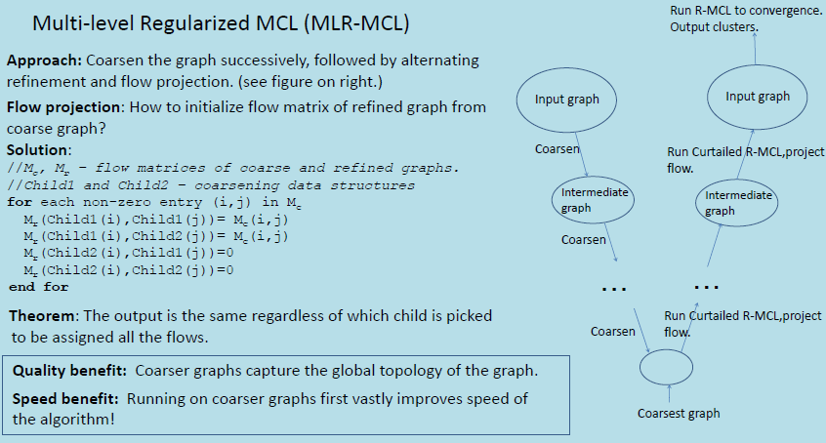

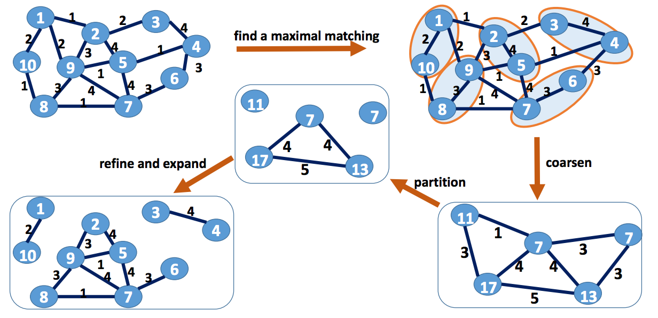

**Figure 1: MLRMCL operations - (Venu Satuluri 2012)**

MLR-MCL operates in three phases, namely:

1. Coarsening
2. Curtailed RMCL with refinement
3. RMCL on original graph

### 3.2.1 Coarsening

Given an input graph G, coarsening will reduce G into a series of smaller graphs G1, G2 … Gi, where Gi will be a graph of reasonable size (a few hundred nodes usually). This allows a first approximation to the original graph topology on a large scale in an insignificant running time when compared to the size of the original problem. In terms of time complexity, this is the most important stage because the faster the coarsest graph can be generated, the more efficient the algorithm will be. Like every multilevel scheme for coarsening, matching pairs of vertices are represented by one single vertex in the coarsened space. For this project, *Maximal matching [2]* is used to pair vertices. For any vertex that has no unmatched adjacent vertices, it is matched with itself (***Figure 2***).

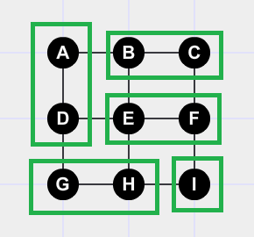

**Figure 2: Maximal Matching**

The matching information will be stored in an array list where it is constructed in a way such that for all i, 0<i<|V|, match[match[i]] = i.

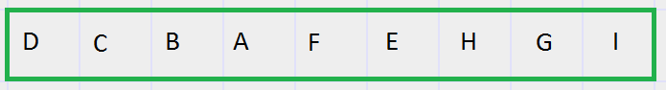

**Figure 3: Matching pairs**

For example, nodes (B, C) is a matched pair, hence match[1] = C and match[2] = B. If a node does not have any matches, it will match with itself, etc: match[8] = I.

Vertex labels for the vertices of G0 will represent one super node of G1 and so on, where G0 is the original graph. This mapping information will be stored in another array list: cmap where cmap[i] = cmap[match[i]]. This ensures the matching in i and match[i] will be united into a single super node during the forming of a coarse graph. 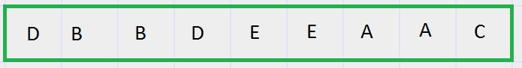

**Figure 4: Mapping to supernodes**

From ***Figure 3***nodes (B,C) is a matched pair and thus it can be mapped into a single super node where cmap[1] = cmap[2] = B (***Figure 4***).

In order to create a coarse graph, the edges connecting the matching vertices are removed and collapsed to form a single super node. Two arrays namely, NodeMap1 and NodeMap2 are added to keep track of the information about the coarse graph. NodeMap1[i] will store the first vertex of the matched pair of the collapsed graph to give vertex i in the coarse graph. Similarly, NodeMap2[i] will store the second vertex of the matched pair in the collapsed graph.

### 3.2.2 Curtailed R-MCL

The second phase of MLR-MCL is to apply an abbreviated version of R-MCL, also known as Curtailed R-MCL. It simply means R-MCL is run for a few iterations on the coarsest graph first and then projected onto the refined graph, iteratively repeated until the original graph is reached. The idea behind running R-MCL with a few iterations on the coarse graphs is to prevent flows in intermediate coarse graphs to converge. Once R-MCL is run until convergence on any of the intermediate coarse graphs, the same clustering results will carry over till the original graph problem. This defeats the purpose of the whole algorithm, putting all the additional information of the coarsening space to waste. However, better cluster quality can be achieved by allowing the flow values to capture the global topology of the original graph. Therefore, running R-MCL only for a few iterations will give better results. R-MCL is run two times in this project.

### 3.2.3 R-MCL on original graph

Finally, R-MCL is run on the original graph similar to MCL until convergence. Attractor nodes and nodes that are being attracted will be swept into similar cluster groups.

### 3.2.4 Multi Core-Processing

As discussed from the time complexity in MCL, MLR-MCL’s regularized function also takes O(n^3). It is noted from the experiment that runtime is connected to the number of nodes. By conducting a simple test on the function, it was discovered that in 1 second, on average there are 65536 iterations.

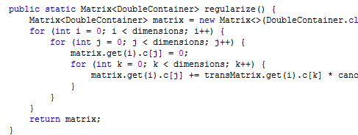

A closer look at MLR-MCL’s coarsening function reveals potential for further improvement. The code above shows that it is possible to use multi-threading for MLR-MCL to boost the computing speed. A fast parallel implementation of the most time consuming region of the sequential MLR-MCL algorithm have a speed up relative to the cores in a computer.

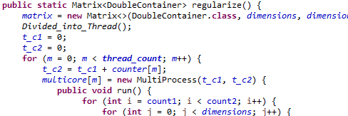

In this modified function, thread count is set 7. This is because most computers support Core™i7. This makes the program dependent on the processor.

### 3.2.5 Analysis

Although the running time of the regularized step in MLR-MCL is similar to the expansion step in MCL, subsequent regularized steps can be approximated as O(k*|E|) where k is the average number of nonzero entries per column. After the first initial RMCL is run on the coarsest graph first, there are rarely more than a few tens nonzero entries per column. The overall time complexity can be approximated to be  [1] p59, where d(i) are the degrees of the nodes in the coarsest graph and k is a small constant. In programming terms, using multi-core processing will further reduce the time taken to about 10 times for the first RMCL iterations where is the most time consuming.

The quality of clusters improves in a multi-level framework. This is because coarsening the graph allows the algorithm to utilize the global topology of the graph that allows initialization of flow values when simulating on larger graphs. Moreover, since iterations are run on the final graph to convergence, the algorithm is able to capture local topology as well. Therefore, MLR-MCL provides faster performance and better quality of clusters for large graphs than MCL.

## 3.3 Chinese Whispers Algorithm (CW)

Chinese whispers, a basic yet effective algorithm is experimented in this project because of its linear time complexity and its similarity to MCL. It aims to find groups of nodes that broadcast the same message to its neighbors [7]. The algorithm is as follows:

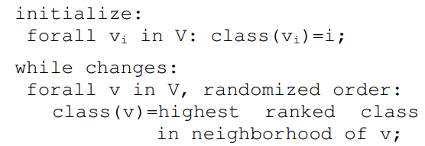

Firstly, all nodes are assigned to different classes. Like MCL, each node is processed iteratively by inheriting the strongest class in the local neighborhood. That is, the class where the sum of edge weight is maximum to the current node. In addition, if there are multiple strongest class available, only one of them will be randomly chosen. The true strength of this algorithm is that classes are updated immediately; a node can obtain classes that are introduced within the same iteration.

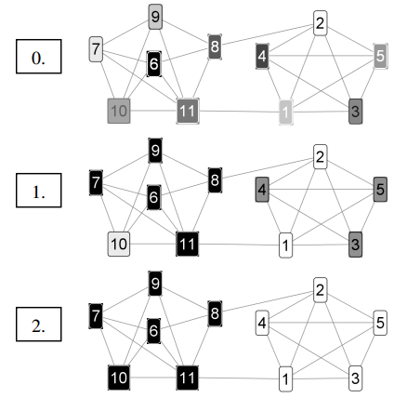

**Figure 5: Clustering based on classes – (Chris Biemann 2011)**

From ***Figure 5 (Chris Biemann 2011)***, we can see eleven nodes that are clustered into two different groups in two iterations. The number of iterations is proportional to the diameter of the graph.

### 3.3.1 Special case of MCL

CW is a special case of MCL where it is also a parallel simulation of Markov chains in a graph G. CW uses a row-wise operator (maxrow) on a matrix and sets the largest entry to 1 while the rest will be set to 0. The algorithm is as follows:

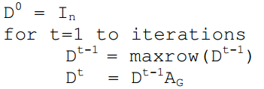

This means that time complexity is dependent on the number of edges namely, O(|K| * |E|). In comparison, MCL’s matrix operations in the expansion step have a time complexity of O(n^3). Due to the stepwise update of the class matrix, there is also a chance that the classes might not converge and will oscillate.

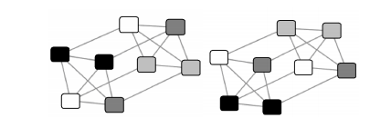

**Figure 6: Converging problem - (Chris Biemann 2011)**

To prevent this from happening, a few steps can be implemented.

1. Random mutation of some probability such as maxrow places 1 for an unused class.
2. By keeping classes, the row is copied from D^(t-1) to D^t.
3. Each class gets updated continuously and immediately.

### 3.3.2 Analysis

Due to random order processing and possible ties, CW is nondeterministic. This is clearly a drawback, however, this is not severe for real world data as most of them are large in size. The reason for this is explained in the following section using a five bipartite-clique graph as an example,

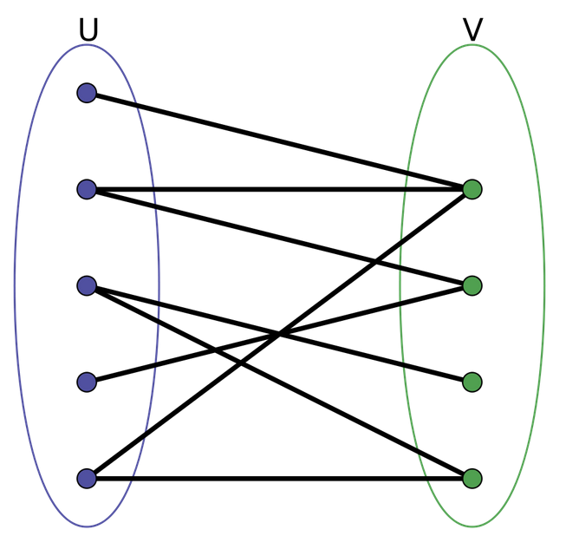 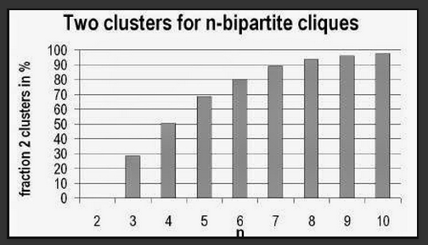

**Figure 7: Bipartite graph Figure 8: Graph size matters for split-(Chris Biemann 2011)**

By intuition, cliques’ U and V from***Figure 7***should be split into two cliques, into two parts or combine them into one cluster. However, there is a percentage of obtaining two different clusters when using CW on n-bipartite cliques. Therefore, the problem will not occur if the graph is large in size as shown in ***Figure 8 (Chris Biemann 2011).*** Hence, the measure on how often CW succeeds is the larger the graph, the saver the split.

Time complexity increases linearly with the number of nodes and this results in fast detection of communities in a network. With a high amount of nodes in a graph, the algorithm is a good tool to analyze community structures in a graph with reasonable accuracy.

# 

# 4. Visualization of evolving clusters

The visualization of evolving clusters is the central issue in the context of clustering dynamic graphs. A static image of a dynamic graph cannot represent change occurring in an evolving network. Clusters need to be tracked over time, and clusters or communities of a single snapshot are often called local according to their associated communities. These clusters that are put together describes the evolution of a certain meta-community over time. In this project, only offline networks are taken into account with the complete time-stamped data available for analysis. 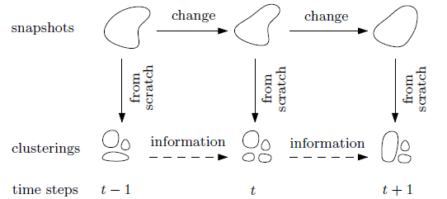

**Figure 9: Evolutionary clustering strategy - (Tanja Hartmann 2014)**

To streamline the evolutionary clustering strategy in evolving graphs, a static clustering approach is applied from scratch on snapshots (***Figure 9 Tanja Hartmann 2014***). Assuming the cluster structure of the graph is already given from consecutive snapshots by any of the 3 algorithms created, detecting the evolution among the clusters over time becomes an independent task, separated from finding the clusters. To interpret the evolution, approaches include seeking series of similar clusters in consecutive snapshots, identifying critical events where clusters split or merge. Furthermore, if a cluster disappears and reappears in future time steps, it requires future information. Finally, as densely connected communities are extracted based on the union of time-steps, it does not guarantee that each cluster of each time-step is densely connected.

The approach is to first compare each time-step cluster in the current time-step pairwise with the time-step clusters of the previous time-step. Next, the overlapping clusters is used as a similarity measure and considers two clusters as similar if the value exceeds a given threshold. If the two clusters are pairwise disjoint, it is called disjoint, otherwise it is overlapping. The reason of finding overlapping nodes is because it can potentially uncover deeper hidden patterns such as small communities persistent over time. This framework can be applied to any cluster structure in any network without regards to which clustering algorithm is used to find this structure. However, it must be noted that depending on the static clustering algorithm used, the cluster structure may vary greatly such that tracking method may find a lot of different edge points instead of supposedly evolving clusters.

# 5. Software resources

## 5.1 Application architecture

### 5.1.1 JAVA and JAVAFX

Java is a high-level, platform-independent, object-oriented programming language. It is typically compiled to class files that are interpreted by a Java virtual machine (JVM). This means Java programs can run on any machine that has JVM installed, making it one of the most popular programming language today.

JavaFX is a Java API that used libraries to access native system capabilities and connect to middleware applications. JavaFX applications can be customized by CSS and separates appearance with implementation.

### 5.1.2 Development tool - NetBeans

NetBeans is a multi-language software development environment that consists of a workspace and multiple plugins for customizing the environment. The software itself is written mostly in Java. NetBeans has a tightly integrated JSP/Servlet/JSP development environment and connects workflow together from development, debugging and deployment.

## 5.2 Libraries

### 5.2.1 Graph Stream

Graph Stream is a graph handling JAVA library that focuses on the dynamic aspects of graphs. It is able to model dynamic interaction networks and consists of several graph classes to model both directed and undirected graphs. Graph evolution in time can be captured by handling the way nodes and edges are added and removed.

### 5.2.2 Guava

Guava is a very well designed Java library documented API developed by Google. It greatly benefits from modern Java features such as generics and auto-boxing. Widely considered to be Apache Commons counterpart, it is still in active development and follows many design patterns that make the code tighter and more expressive.

# 

# 6. Design documentation

The project was carried out in two major phases: implementation of clustering algorithms and a dynamic visual representation of clustering results. Discretization of the dynamic network into series of static networks allows the extension of static clustering techniques to be applicable.

## 6.1 Clustering Algorithms

The algorithms are first designed and tested with a very small number of nodes. Typically, it consists of around 5 to 10 nodes. The next step is to manually calculate the matrices for input graphs based on the algorithm. Matrix values can then be verified step by step and cross checking the algorithm based output is less time consuming. In order to have different snapshots of a dynamic graph, the time dimension t is divided to a set of intervals, for example, [1, 50], [51, 100], [101, 150]. For each of the interval etc; [1, 50], a graph snapshot G1 is constructed with all the temporal edges (u,v,t,d) satisfying the conditions (1<=t<=50) and (t+d<=50) as edges of the snapshot. This allows multiple snapshots G1, G2, ...Gi of the same dynamic graph. Finally, the clustering algorithm will then be applied on every snapshot.

### 

### 6.1.1 Snapshots

An example of a graph snapshot for a network of threads (slashdot.edges) between time i to time k can be visualized using *Gephi*, an interactive visualization and exploration platform.

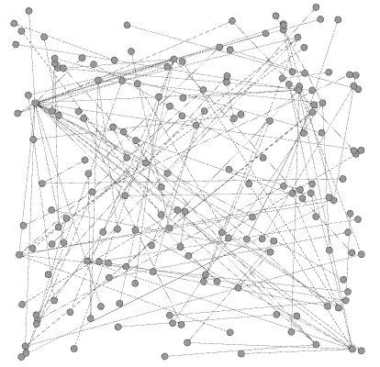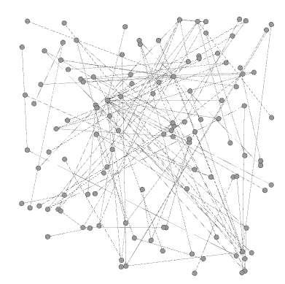

**Figure 10: Snapshot at time step 1** **Figure 11: Snapshot at time step 2**

From ***Figure 10***, the graph consists of 173 nodes and 137 edges at time [0,100]. The graph then can be seen to change its shape dynamically at ***Figure 11*** where time [100, 200] is shown to consist of 116 nodes and 116 edges. In order to allow Gephi to interpret the inputs, a hash map (***Figure 12***) is generated for each time interval. Finally, the hash map will then be converted into CSV format and fed into Gephi visual framework.

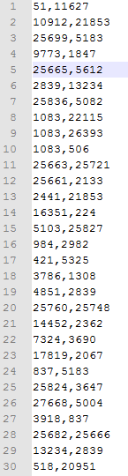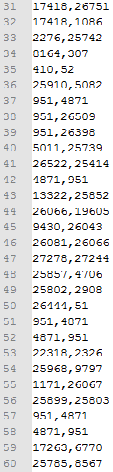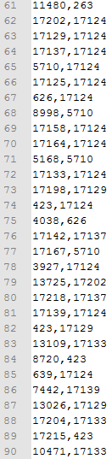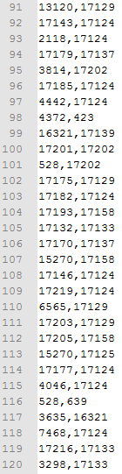

**Figure 12: Hash map to CSV format**

### 6.1.2 Detailed cluster results

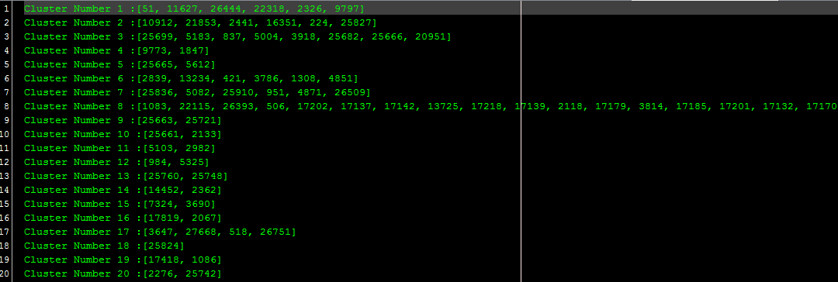**Figure 13: Node details displayed at each cluster**

Every node will end up in at least one cluster, that is if a node degree is 0, then it will be allocated alone in a cluster. One example would be cluster 18 in ***Figure 13*** as it shows a node that is disconnected from the graph.

## 6.2 Linking and analysis

To demonstrate the evolvement of clusters, a visual representation was implemented using Graph Stream API. The links between clusters are established based on overlapping nodes. Two sets of clusters, one set S1 from t1 where t is the time interval, and another set S2 from t2 were given. Suppose S1 contains 5 clusters C11, C12, ... , C15 and S2 contain 4 clusters C21, C22, … , C24 where C is the cluster number, the similarity between any cluster in S1 and any cluster in S2 is computed by taking the number of common nodes in them. This will then form a complete bipartite graph. If C11 from t1 has 10 nodes and among these 10 nodes, 6 goes to C22 and 4 goes to C23. This can be interpreted as C11 at t1 has been split into C22 and C23 at t2. An example is given below:

t = 1: Cluster # 1 [101, 106, 107, 108, 111, 113, 114, 115, 116, 117, 118, 119, 120, 121, 122, 123, 163, 2, 429, 8284, 94]

t = 2: Cluster # 1 [101, 107, 114], Cluster # 3 [108, 117, 120, 121]

There is a link from Cluster 1 at t=1 to Cluster 1 at t=2, similarly, a link from Cluster #1 at t=1 to Cluster 3 at t=2. This will give the effect that Cluster # 1 at t = 1 splits into two clusters at t = 2.

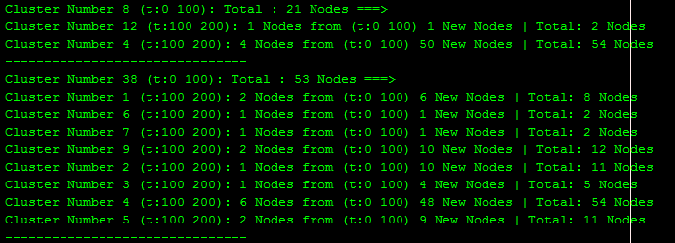**Figure 14: Tracking node information in clusters**

Using slashdot.edges time interval [0,100] and [100,200] as a real graph result, ***Figure 14*** shows the clustering results of MLR-MCL. Cluster 8 at the time step [0, 100] is shown to have 21 nodes and 5 nodes is shown to be overlapping between cluster 12 and 4 at the time step [100, 200]. Because the graph is continuously evolving at each snapshot, there are new nodes that appear in time [100, 200].



**Figure 15: Visualization model**

This format is then fed into the visualization library designed to interpret the evolution of the clusters. ***Figure 15*** shows the two-time intervals clustering results namely: [0, 100] and [100, 200] from elec.edges satisfying the condition if at least one overlapped node exists between two intervals. To give users a better intuitive understanding of how the graph structure is like, clusters’ size corresponds to their total nodes using a simple sizing formula. Moreover, the edges’ thickness also corresponds to their overlapping nodes using the exact same formula.

### 6.2.1 Threshold





**Figure 16: Continuous time intervals**

The visual library is scalable and is able to accept continuous time intervals (***Figure 16***).

Further functions were implemented as part of the visual analysis development.

For each pair of linked clusters, the program will compute the number of overlapping nodes. For example, the highlighted link shows that between C1: [0, 100] and C2: [100, 200] there is a node that is overlapping between these two clusters.

To show the relationships between clusters, an additional function is implemented such that when C2: [100, 200] is clicked, it shows all the cluster information (totally nodes) that has a relationship with it.



**Figure 17: Threshold at 30%**

In addition, the ratio of the overlapping nodes over the cluster in the first time step will be computed and tested against a given threshold. To illustrate this concept, if the ratio is greater than a threshold, for example, at 30% the program is able to create a link between the two clusters. ***Figure 17*** shows the links are changed when the threshold is >= 30%.

The first time stamp is denoted by totalParentNodes and overlappingChildNodes indicates similar nodes that appeared in both time intervals. To calculate the threshold, the formula **( overlappingNodes / totalParentNodes) * 100.0** is used. In ***Figure 17***, if the threshold is set to 50%, then the graph will only show 4 links between the two-time intervals.

### 6.2.2 Tracing



**Figure 18: Tracking node ID 80**

The tracing feature can be seen from the above figure where node id 80 is traced giving the impression that it is likely to be involved in sequences of clusters in following time steps.



**Figure 19: Reappearing node ID 78**

Tracing can also be used to identify nodes that disappeared and reemerged in another time step. Temporal tracing helps highlight relations between feature patterns and graph properties as it shows the evolution of the global structure of the graph. Node id 78 is shown to be present in time step 1 but disappeared during time step 2 only to reappear in time step 3, 4 and 5.

# 

# 

# 

# 

# 

# 

# 6.3 Experimental Results:

## 6.3.1 Performance

**Results:** Cluster information obtained at a specific time t. CW is run multiple times to obtain the average range of clusters.

**Graph1:** [**http://konect.uni-koblenz.de/networks/elec**](http://konect.uni-koblenz.de/networks/elec)

**Graph2:** [**http://konect.uni-koblenz.de/networks/munmun_digg_reply**](http://konect.uni-koblenz.de/networks/munmun_digg_reply)

**Graph3:** [**http://konect.uni-koblenz.de/networks/slashdot-threads**](http://konect.uni-koblenz.de/networks/slashdot-threads)

**Time step = [0, 1000]**

|  |  |  |  |
| --- | --- | --- | --- |
| No. of clusters | Graph1 | Graph2 | Graph3 |
| MCL | 26 | 396 | 320 |
| MLR-MCL | 18 | 163 | 110 |
| CW | 1 | 262 - 271 | 146 - 151 |

Graph 1: 3121 Nodes edges: 278

Graph 2: 1034 Nodes edges: 1146

Graph 3: 1532 Nodes edges: 1148

**Time step = [0, 3000]**

|  |  |  |  |
| --- | --- | --- | --- |
| No. of clusters | Graph1 | Graph2 | Graph3 |
| MCL | 53 | **\*** | **\*** |
| MLR-MCL | 23 | 349 | 213 |
| CW | 1 | 557 - 590 | 290 - 325 |

Graph 1: 3121 Nodes edges: 534

Graph 2: 3101 Nodes edges: 2909

Graph 3: 4461 Nodes edges: 2878

**Time step = [0, 5000]**

|  |  |  |  |
| --- | --- | --- | --- |
| No. of clusters | Graph1 | Graph2 | Graph3 |
| MCL | 83 | **\*** | **\*** |
| MLR-MCL | 20 | 453 | 272 |
| CW | 1 | 767 - 801 | 426 - 450 |

Graph 1: 5161 Nodes edges: 746

Graph 2: 5189 Nodes edges: 4439

Graph 3: 8097 Nodes edges: 4796

**\*: infeasible time - Due to expansion step**

As discussed previously, MCL’s iteration rises exponentially due to its expansion function, and hence it was not feasible to do further testing after 3000 nodes. MCL is chosen as a base algorithm in this project to further improve on its strengths and eliminate the weaknesses resulting in the implementation of MLR-MCL. Therefore, MLR-MCL is considered to be vastly superior in all aspects.

An interesting thing to note is on Graph 1, CW has only one cluster. It is possible that since Graph 1 is especially sparse, in other words there are few edges, CW will not find any communities and instead group all nodes as one cluster. A way to modify the number of clusters is to change the random mutation rate that will assign new classes with a certain probability decreasing in the number of iterations.

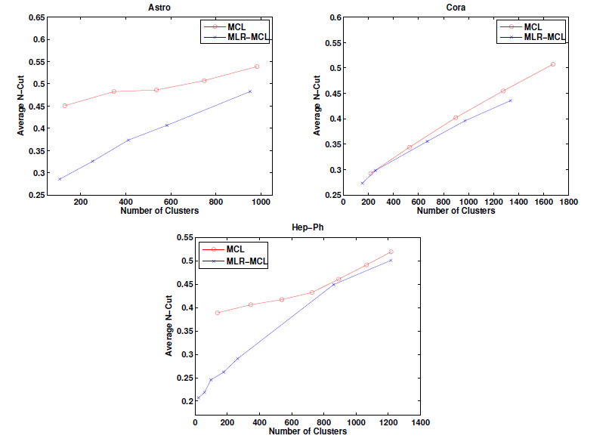

**Figure 20: Average N-CUT of MCL and MLRMCL (Macro Gaertler and others 2011)**

The cluster quality was not directly measured in this project but was referenced according to the research article [1], ‘Scalable Clustering of Modern Networks’ p64. The cluster quality is measured according to the average normalized cut. From the experiment results, it can be noted that MLR-MCL is indeed producing fewer clusters and corresponds to the dissertation’s statistics.

## 6.3.2 Comparison Results

In this section, the comparison results will be analyzed and discussed. The nodes involved in each comparison will symbolize the communities that are involved during the progression to the next time frame. It must be emphasized that time steps employed is not suggested but are arbitrary, and this is an issue of using the analogy of snapshots to an evolving network. Small time steps between each snapshot preserve resolution but might ignore wider trends that can occur over longer timescales. Conversely, using larger time steps might detect more events (merging, splitting) but loses the temporal order of events within each snapshot. Thus, an appropriate timescale for dividing the evolving network is difficult to achieve. In this project, a time step of 100 is used for experiments.

Finally, the number of overlapping nodes will be calculated to the similarity between two-time steps’ clusters.

**Number of Clusters involved**

**Graph 1**

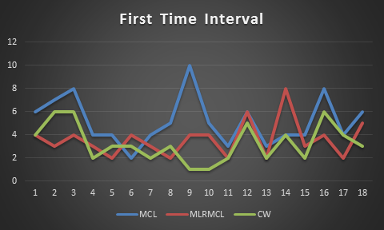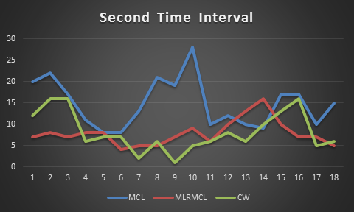

**Graph 2**

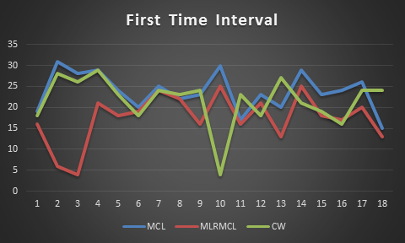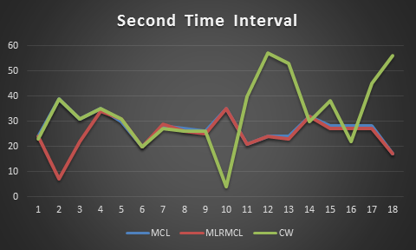

**Graph 3**

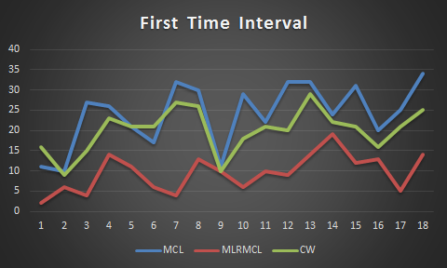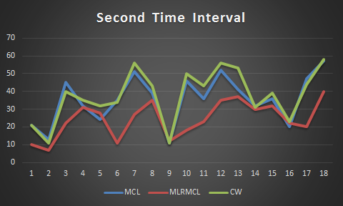

**Figure 21: Number of clusters involved in graphs**

In this experiment, once an overlapping node is discovered, the clusters that contain this node will automatically be considered as part of the visual model. It is expected that MLR-MCL involves the least clusters because of the amount of clusters produced. Figure 6.11 clearly illustrates that MLR-MCL overcomes the main qualitative limitation of cluster fragmentation even in the similarity algorithm. MLR-MCL is also shown later to also capture almost the same amount of overlapping nodes as the other two algorithms which further emphasize the superior quality of its clusters.

**Number of overlapping nodes**

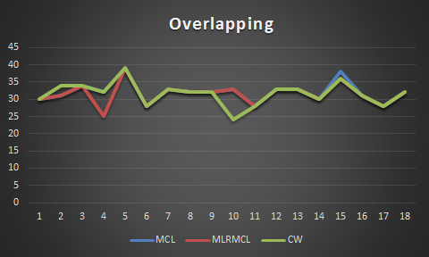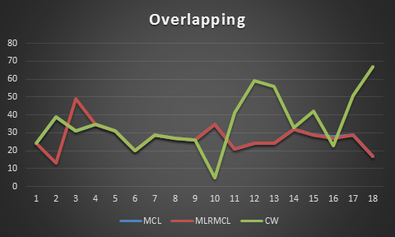

**Graph 1**  **Graph 2**

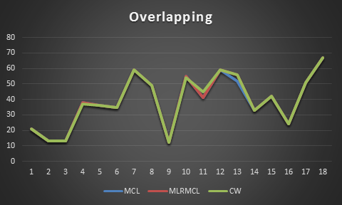

**Graph 3**

**Figure 22: Number of overlapping nodes in each graph**

It is interesting that the number of overlapping nodes remains reasonably consistent even though the number of clusters and nodes involved varies among all 3 algorithms. MCL and MLR-MCL in graph 2 have almost the same amount of overlapping nodes while in graph 3, all 3 algorithms are producing an almost identical amount of overlapping nodes. In addition, CW tends to be different in capturing similarity between clusters as noted from Graph 2.

In conclusion, both MCL and MLR-MCL is similar in capturing similar overlapping nodes but differs in terms of cluster count. CW depends on the time step length and thus not suitable for shorter time steps because of its non-deterministic nature.

# 7. Conclusion

Clustering dynamic networks is at least as difficult as compared to clustering static networks because not only does it inherit all the difficulties in the static case, many more problems are faced that are a result from the evolution of networks. Static graph clustering considers what a good clustering is and performance of clustering algorithms because of the absence of approved performance benchmarks. In addition to these difficulties, clustering dynamic networks involves detecting and visualizing the evolution of clusters over time. The approach taken to study an evolving network is to consider a sequence of snapshots and each of these snapshots is regarded as a static network. Among the vast number of algorithms designed to detect clusters in graphs, this project considers 3 graph clustering algorithms. In terms of clustering algorithms based on multi-level simulations of stochastic flows, the project proposes Multi-Level Regularized MCL. These algorithms were then analyzed in terms of performance and speed. Next, a comparison model that uses overlapping nodes as a similarity measure is constructed and all 3 algorithms is shown to produce similar results. Furthermore, a graphical user interface was designed to allow users to visualize the evolution over time using a threshold as a reference for constructing links between time step clusters. This work is a first step towards a unified foundation for generalized clustering of graphs, including dynamics. Future work can be dedicated to utilizing, refining and further developing the visual model specifically in dynamic networks.

# 8. Future work

1) The matrix multiplication time complexity of O(n^3) becomes more costly as the graph gets sparser. Multi-core processing using thread pools has been implemented to utilize the CPU at 100% core capacity to speed up this step. However, if some parallel architecture is provided to optimize sparse graphs, it can be taken as a reference.

Considering a graph such as elec.edges in this project, the number of edges pales significantly in comparison to its vertices. It is easy to see that the connectivity matrix is large and extremely sparse. Thus, it is recommended to design clustering algorithms based on MapReduce to express the probability matrix in such a way that 0 values are not included in the procedure.

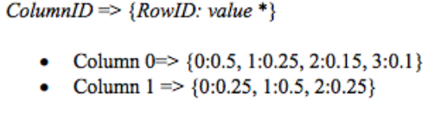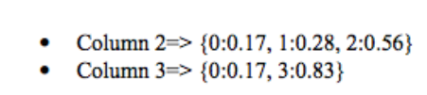

Using this method proposed, the whole column of data will be retrieved first using row index to find a corresponding value. In this way, it will take less storage space as it records every column index once. In MCL, data is loaded by row and column, benefitting both time and space performance [11].

2) Series of graph snapshots that represent the network at different points of time not only requires large storage capacity but also means significant querying time. There are very few works that can handle dynamic networks at the scale of many of today’s large real-world networks. To enable a scalable management of these dynamic graph data, G* system can be extended to efficient storage and query snapshots on multiple worker servers using commonalities among the snapshots [8]. Querying big snapshots can be parallelized using query-aware replica selection and splitting techniques.

3) In this project, the approach is based on executing the clustering algorithm from scratch in each time step. Instead of computing from scratch, clusters can be dynamically updated with information found in previous time steps.

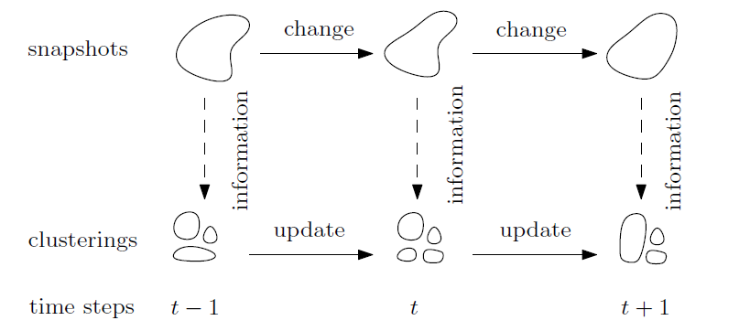

**Figure 23: Dynamic update strategy – (Tanja Hartmann 2014)**

From ***Figure 23 (Tanja Hartmann 2014)***, the horizontal arrows show the dynamic update strategy in reference to the previous time steps [9] p3. It has to be noted that depending on the clustering algorithm in which this temporal smoothness is incorporated, it may result in an objective function that requires to be optimized such as an adaption of an input data with certain parameters. This evolutionary clustering, as it is known, is a shortcut that not only allow smooth transitions but also saves valuable computation time.

# 

# References

[1] Venu M. Satuluri, “Scalable Clustering of Modern Networks” The Ohio State University, 2012

[2] Zardosht Lasheff, “Partial Parallelization of Graph Partitioning algorithm Metis, MIT, 2003

[3] Venu Satuluri, Srinivasan Parthasarathy, “Scalable Graph Clustering using Stochastic Flows, The Ohio State University, 2009

[4] Srinivasan Parthasarathy and others, “Component Detection in Directed Networks” The Ohio State University, 2014

[5] Kathy Macropol, “The Markov Cluster Algorithm”, Uc santa barbara, 2009

[6] Srinivasan Parthasarathy and others, “Directional Component Detection via Markov Clustering in Directed Networks”, The Ohio State University, 2013

[7] Chris Biemann, “Chinese Whispers - an Efficient Graph Clustering Algorithm and its Application to Natural Language Processing Problems”, University of Leipzig, 2011

[8] Alan G.Labouseur and others, “Scalable and Robust Management of Dynamic Graph Data”, State University of New York, USA, 2014

[9] Tanja Hartmann and others, “Clustering Evolving Networks”, Department of Informatics, Karlsruhe Institute of Technology (KIT), 2014

[10] Marco Gaertler and others, “How to Cluster Evolving Graphs”, Faculty of Informatics, Universit¨at Karlsruhe (TH), 2014

[11] Nan Gong, “Using Map-Reduce for Large Scale Analysis of Graph-Based Data”, KTH Information and Communication Technology, 2011

[12] S. Van Dongen. A new cluster algorithm for graphs. Report No. INS-R0010, Center for Mathematics and Computer Science, Amsterdam, 2000.

# 

# End Section

## Appendix A

All 3 graph clustering algorithms are written by myself with reference to the research papers indicated in the reference page. Chinese Whispers Algorithm was implemented using the distributed version via jar files provided in the archive <http://wortschatz.uni-leipzig.de/~cbiemann/software/CW.zip> partially.

### Algorithms functionality

Each algorithm produces clusters details of each time step in the format data<time step><algorithm name>Results.txt

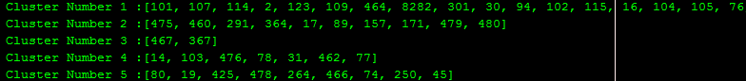

Each algorithm will produce a comparison file in the format data<time step 1><time step 2><algorithm name>Results.txt

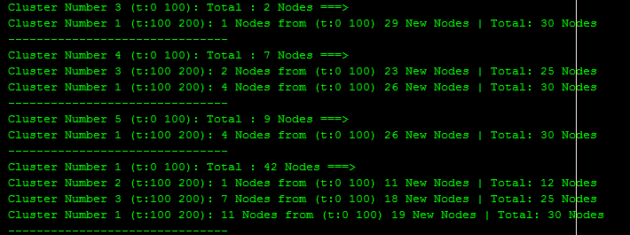

To enable in-depth analysis of cluster nodes, each algorithm will also produce a comparison file in the format detailed_data<time step 1><time step 2><algorithm name>Results.txt

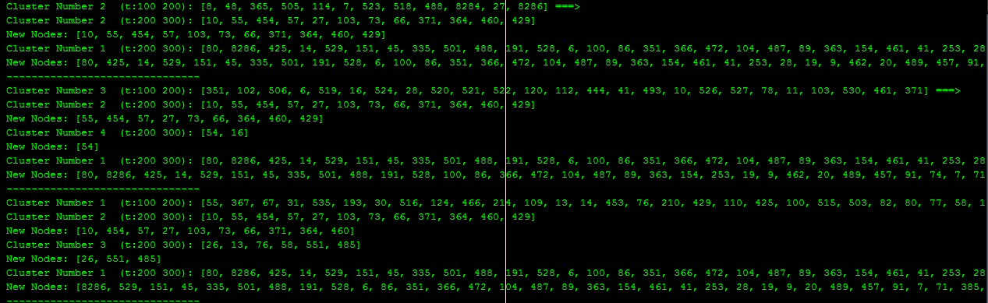

### Visual model functionality



The visual model is able to take a snapshot of the graph to enable ease of analyzing multiple images.

When clicked, the screenshot of the graph will be saved into the source folder.



By enabling options “Node Details”, the visual model will read the detailed_data comparison file for users to trace nodes. This is to allow edges value (overlapping nodes) to be displayed for analysis.



The user is also able to select one of the 3 clustering algorithms comparison results to analyze provided the files are in the resource folder.



The user is able to trace node ID 80 directly from the “trace input field” and clicking the button “Trace”. By also clicking the “Reset” button, the graph will automatically erase all highlighted edges.



The user is also able to key in different time steps and automatically create a new graph by inputting in the “Create Chart field” and clicking “Create Chart”.



The user can also assign a threshold on the spot and update the graph by inputting the “Threshold field” and clicking the “Threshold” button.

## 

## 

## 

## 

## Appendix B (Test results)

### Number of Nodes involved

**Graph 1:**

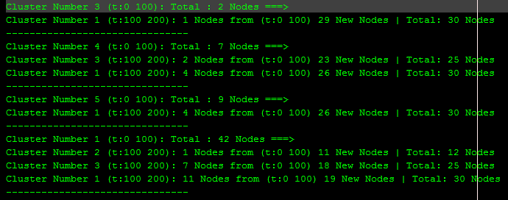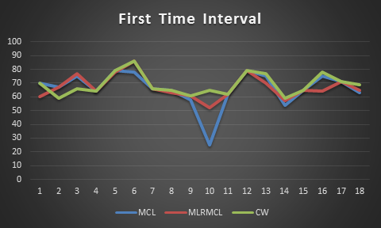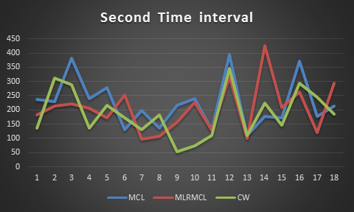

**Graph 2**

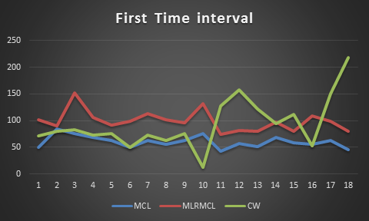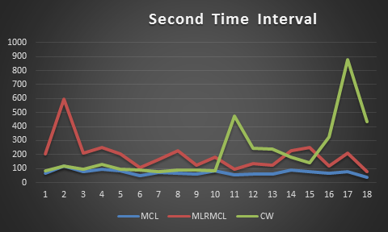

**Graph 3**

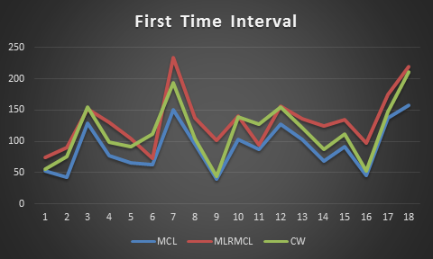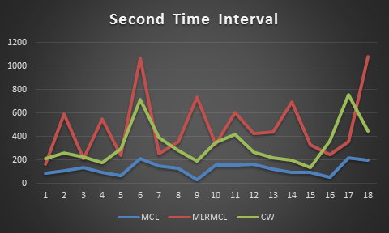

The above figure shows the number of nodes involved during time steps. The nodes involved are only those that shows up in the comparison algorithm.

This experiment was done on a pair of time steps, etc [0,100,100 200] (Figure 6.12). First time step refers to [0,100] and second time step refers to [100,200]. The above figure shows only the variation of captured nodes in each algorithm.

**Graph 1:**

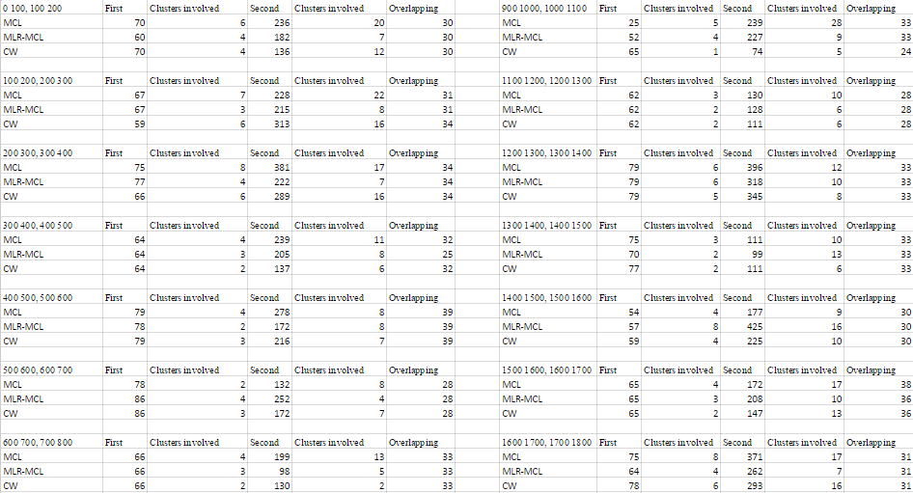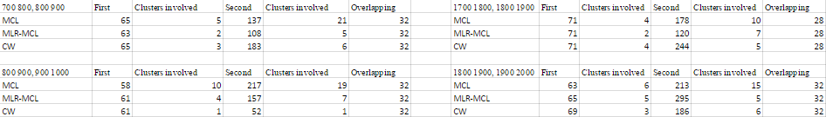

**Graph 2:** 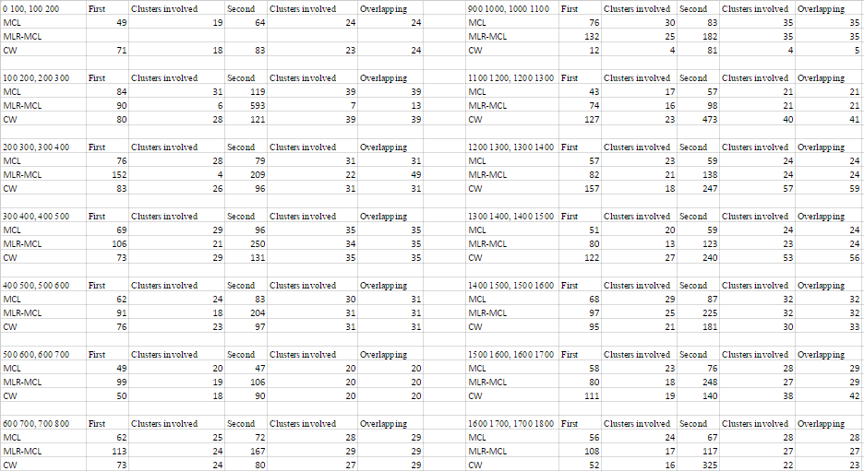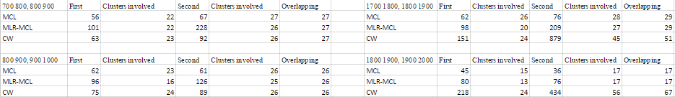

**Graph 3:**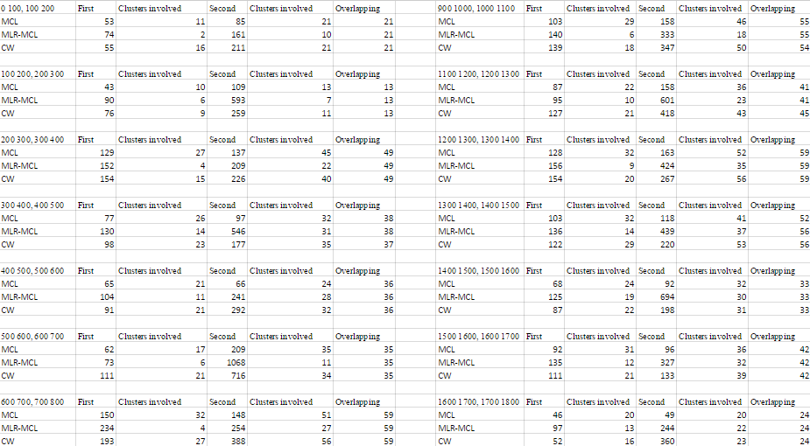

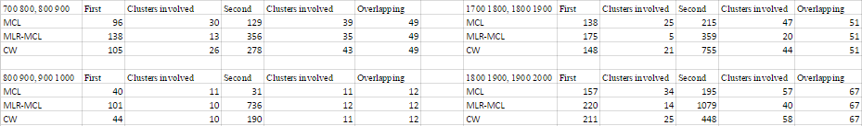

## Appendix C (Visual Model Instructions)

|  |  |  |  |  |
| --- | --- | --- | --- | --- |
|  | Title | Input | Steps | Expected Result |
| 1 | Setting threshold value | 0 100,100 200,200 300,300 400,400 500 | 1. Run the program. | Graph representing nodes satisfying the Threshold value |
|  |  |  | 2. Select the algorithm and enter time steps. |  |
|  |  |  | 3. Enter threshold value and click ‘ Threshold'  button. |  |
|  |  |  |  |  |
| 2 | Showing Nodes Details | 0 100,100 200,200 300,300 400,400 500 | 1. Run the program. | Now you will be able to see the nodes of particular after clicking on nodes of the Graph. |
|  |  |  | 2. Select the algorithm and enter time steps. |
|  |  |  | 3. Select 'Options' menu. |  |
|  |  |  | 4. Select 'Node Details'. |  |
|  |  |  |  |  |
| 3 | Taking Snapshot | 0 100,100 200,200 300,300 400,400 500 | 1. Run the program. | A snapshot of the Graph section is generated at the source of program files |
|  |  |  | 2. Select the algorithm and enter time steps. |  |
|  |  |  | 3. Select 'Options' menu. |  |
|  |  |  | 4. Select 'Take Snapshot'. |  |
|  |  |  |  |  |
| 4 | Changing Algorithm | 0 100,100 200,200 300,300 400,400 500 | 1. Run the program. | A Message Box appears to inform to create new Graph to be able to varry Threshold and Trace node |
|  |  |  | 2. Select the algorithm and enter time steps. |  |
|  |  |  | 3. Select on the pre-selected algorithm. |  |
|  |  |  | 4. Select anyone from the menu. |  |
|  |  |  |  |  |
| 5 | Creating Graph | 0 100,100 200,200 300,300 400,400 500 | 1. Run the program. | A new Graph is created and the contents of the table is changed as per the given range |
|  |  |  | 2. Select the algorithm and enter time steps. |  |
|  |  |  | 3. Enter different range in the text field. |  |
|  |  |  | 4. Click 'Create Graph' button. |  |
|  |  |  |  |  |
| 6 | Tracing Node |  |  |  |
|  | a. By Button | 0 100,100 200,200 300,300 400,400 500 | 1. Run the program. | A Green trace depecting node transition among different clusters, if no transition has taken place appropriate message is generated also show indicates the presence of node in various clusters inspite of no transition |
|  |  |  | 2. Select the algorithm and enter time steps. |  |
|  |  |  | 3. Enter any numeric node value to be searched. |  |
|  |  |  | 4. Click on 'Trace' button. |  |
|  | b. By clicking graph node | 0 100,100 200,200 300,300 400,400 500 | 1. Run the program. | *Same as above* |
|  |  |  | 2. Select the algorithm and enter time steps.  3. Select ‘Options’ menu.  4. Select ‘Node Details’.  5. Click on any node of graph and then select any  button among the buttons. | In addition to this position of the node and value of the selected node is printed in the Text-Field provided to enter Node for tracing |
|  |  |  |  |  |